**Fennec**

**Style**

**Guide**

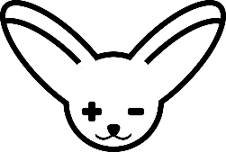

**Fennec is a tool for helping veterinary technician students apply their math skills in realistic treatment scenarios. Our goal is to help students become the best they can be at helping animals live full, healthy lives.**

Who are we?

**Table of Contents**

**Colors**

**Typography**

**Iconography**

**Interaction**

**Voice**

Colors

**The Fennec color scheme is composed mainly of oranges and greens. Orange is the color of our mascot, the fennec fox, and is the dominant color of Fennec. Green is used as a contrasting accent color, such as for interactive elements.**

**255, 226, 205**

**#FFE2CD**

**255, 137, 73**

**220, 109, 50**

**#FF8949**

**#DC6D32**

**#5E60CE**

**255, 244, 235**

**47, 168, 120**

**#2FA878**

**119, 163, 145**

**222, 241, 234**

**#77A391**

**#DEF1EA**

**31, 146, 100**

**#1F9264**

Typography

**Fennec uses Segoe UI as its default sans-serif font and Georgia as its default serif font.**

**Segoe UI**

A a 

A B C D E F G H I J K L M N O P Q R S T U V W X Y Z

a b c d e f g h i j k l m n o p q r s t u v w x y z

0 1 2 3 4 5 6 7 8 9 ! ? @ # $ % & , .

**A a bold** 

**A B C D E F G H I J K L M N O P Q R S T U V W X Y Z**

**a b c d e f g h i j k l m n o p q r s t u v w x y z**

**0 1 2 3 4 5 6 7 8 9 ! ? @ # $ % & , .**

*A a**italic*

*A B C D E F G H I J K L M N O P Q R S T U V W X Y Z*

*a b c d e f g h i j k l m n o p q r s t u v w x y z*

*0 1 2 3 4 5 6 7 8 9 ! ? @ # $ % & , .*

**“Segoe UI is a sans-serif typeface, which supports a sleek, modern, and enjoyable user experience.”**

Typography

**Georgia**

A a 

A B C D E F G H I J K L M N O P Q R S T U V W X Y Z

a b c d e f g h i j k l m n o p q r s t u v w x y z

0 1 2 3 4 5 6 7 8 9 ! ? @ # $ % & , .

**A a bold** 

**A B C D E F G H I J K L M N O P Q R S T U V W X Y Z**

**a b c d e f g h i j k l m n o p q r s t u v w x y z**

**0 1 2 3 4 5 6 7 8 9 ! ? @ # $ % & , .**

*A a**italic*

*A B C D E F G H I J K L M N O P Q R S T U V W X Y Z*

*a b c d e f g h i j k l m n o p q r s t u v w x y z*

*0 1 2 3 4 5 6 7 8 9 ! ? @ # $ % & , .*

**“Georgia is a serif typeface. It’s familiar, readable, and provides an air of professionalism and grace.”**

**Segoe UI should be used for all paragraph, navigation, and card text on the website. Georgia should be used only for headings, such as those on the homepage.**

Iconography

**Fennec uses simple, flat icons to beautify or convey meaning on certain pages and components.**

**Our Logo**

**The Fennec logo encapsulates the partnership between animal care and mathematics. It’s based our animal mascot, the fennec fox, with a plus and minus symbol for the eyes.**

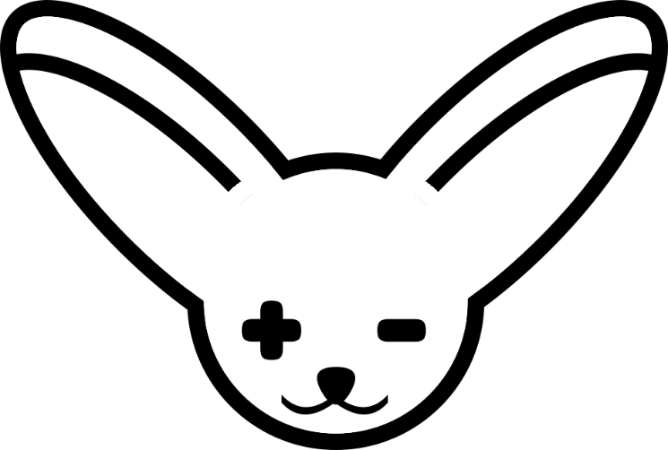

**Sufficient whitespace should be given around the logo to ensure visibility. Avoid scaling the logo down if it blurs the fox’s facial features.**

**The logo should contrast with its background. On dark backgrounds, the logo should be white. On light or medium backgrounds, it should be black. The logo can also be orange on black or white backgrounds.**

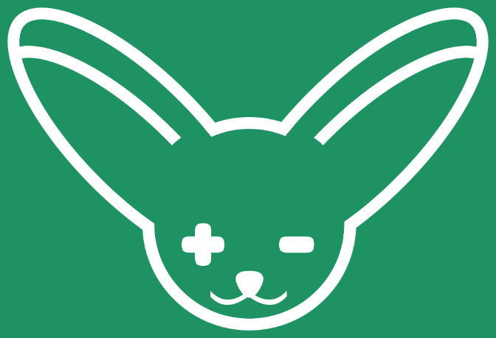 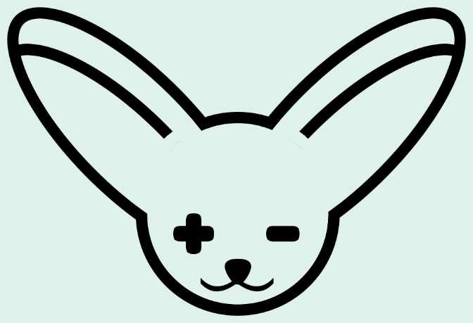

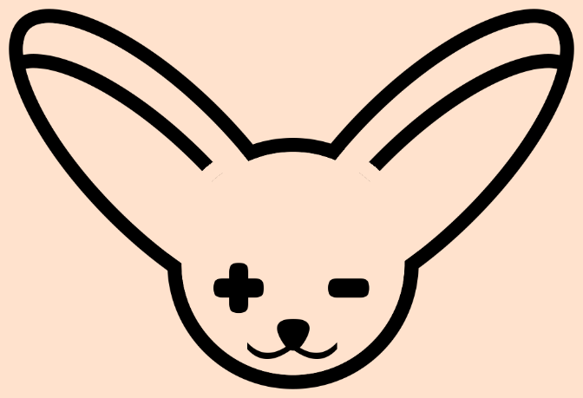 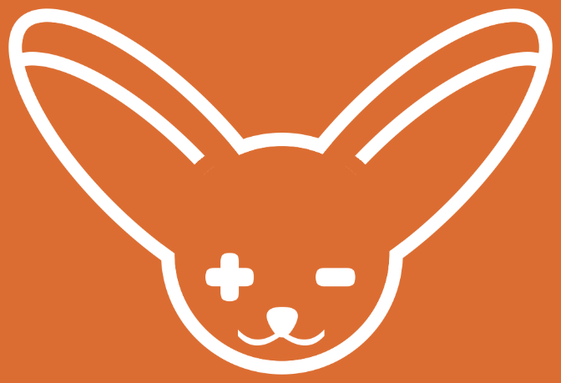

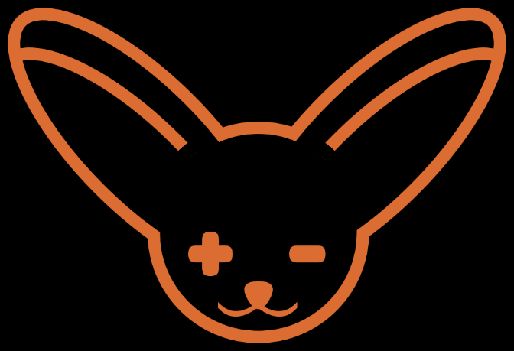

Interaction

**Checkboxes**

**Default Selected**

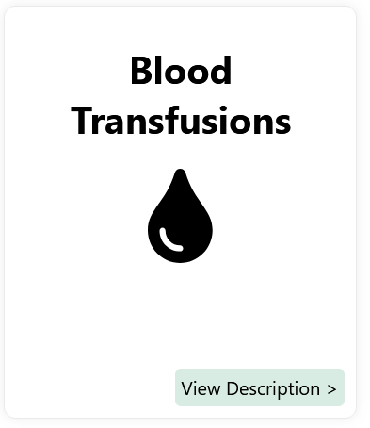 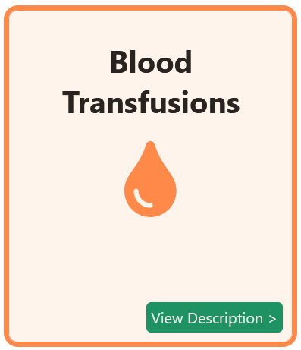

**Buttons**

**Default Active**

** **

and **IS NOT…**

Our Voice

**Intelligent**

**Professional**

**Helpful**

**Clear**

**Educational**

**Cold**

**Inaccessible**

**Annoying**

**Sparse**

**Condescending**

Fennec ***IS…***

Fennec’s goal is to support veterinary technician students in their journey towards a successful education and career by providing relevant learning material. The Fennec brand should reflect this commitment with a straightforward, accessible, and supportive voice.

**Students today, heroes tomorrow.**

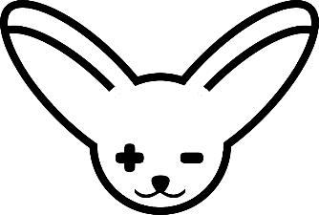

**This guide was developed as a collaboration between**

**Dalhousie University’s Veterinary Technology program**

**and the X691 Computer Science course. It can be used**

**to develop new Fennec tools and learning material.**

**https://ppvt-xu4tpygspa-uc.a.run.app/**